**Sound Reactive Lights**

**Introduction**

Filters are circuits that are capable of passing signals with certain selected frequencies while rejecting signals with other frequencies. **Active Filters**is a type of analog filter that use transistors or operational amplifier with combined passive RC, RL, or RLC circuits. These filters provides not only the selective frequency but also provides a voltage gain. In this project, we will only introduce two of the active filters which are the **Low-Pass** and **High-Pass** filters.

**Low-Pass Filter**. This filter cuts off all high frequency parts of the signal and let the lower frequencies pass the filter. An ideal low-pass filter is shown in figure 1 below. The passband signal serves as the frequencies that will pass through the filter. The cut-off frequency, *fc*, serves as the reference up to where the frequency will flow or in other words, it is the maximum limit of the frequency to pass by the filter. The project that we have made is with the use of an op amp circuit. Figure 2 below shows a sample of this kind of circuit with 1 pole.

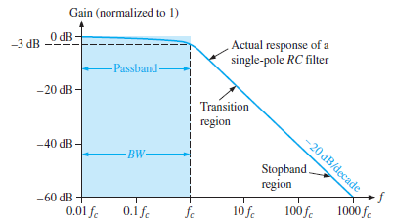

Figure 1: Ideal Low-pass Filter with actual response

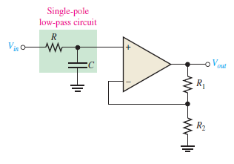

Figure 2: OpAmp Low-pass filter with 1 pole

(boylestad, Electronic Devices 9th Ed.)

**High-Pass Filter**. This filter cuts off all low parts of the spectrum and let the high frequencies pass the filter. An ideal high-pass filter is shown in figure 3 below. The ideal response indicated by blue shaded area has an instantaneous drop at its cut-off frequency, *fc*. Ideally, the passband of a high-pass filter is all frequencies above the critical frequency. The project that we have made is with use of an op amp circuit given an example below with 1 pole.

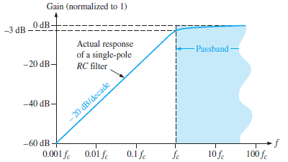

Figure 3: Ideal High-pass filter response

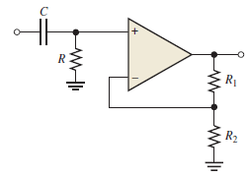

Figure 4: OpAmp High-pass filter with 1 pole

(boylestad, Electronic Devices 9th Ed.)

**Project Description**

Creativity is always a good connectivity to human beings. We want creativity in all of the things to make it presentable. One of being creative is to make thing that is ordinary to be extraordinarily amazing.

One of the application in creativity is by making a sound reactive LEDs. To make this possible, the audio input which is connected through an earphone jack needs to be filter. With the use of high and low pass filter, it can filter out the high and low signal from the input and convert it to an electrical signal to properly react the lights from the LEDs. The high pass filter will pass the treble tone of the music and eliminate unnecessary frequencies. The low pass filter will pass the bass tone of the music and eliminate unnecessary frequencies.

**Schematic & PCB Layout**

Schematic using Electronic Workbench (NI Multisim)

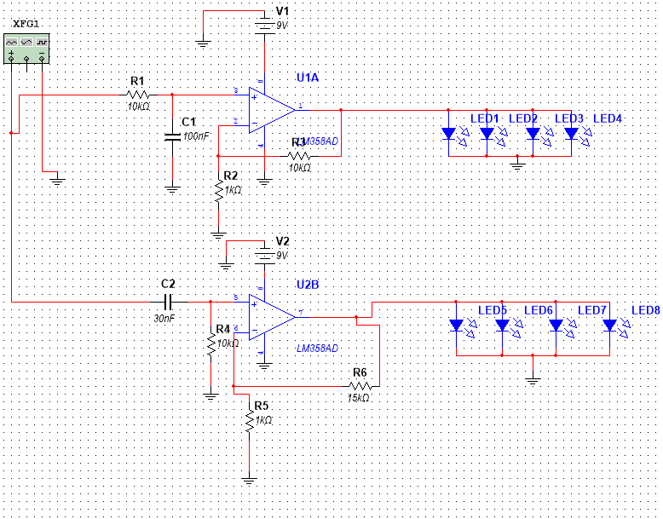

PCB Layout using PCB Wizard

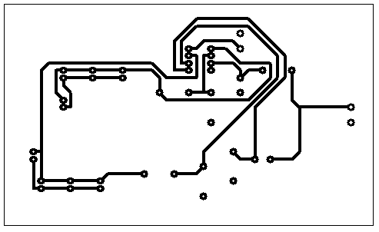

**Materials and Methodology**

Materials used:

9 V battery

LM358D Dual Op Amp

8 pins IC holder

Capacitors (1) 30 nF, (1) 100 nF

Resistors (3) 10 kΩ (2) 1 kΩ (1) 15 kΩ

LEDs (4) Red (4) Yellow

3.5 mm baby jack

The first thing that we did is to configure, simulate and check if the schematic is working with the use of electronic work bench. We configured a low pass and high pass circuit with one pole in each and an op amp. As we saw that it is working, we, then inserted the required components in the breadboard to check if the components and connections are all working. We connected first the LM358 then inserted the capacitors and resistors to its appropriate connection (parallel/series/grounded). After connecting all those components, we tried to make it work by inserting a phone using the 3.5 mm baby jack while playing a music. We saw it working by seeing the red LEDs blinking in synchronize with the bass of the music and the yellow LEDs blinking with the treble. After seeing the working components on the breadboard, we make a PCB layout of the circuit with the use of PCB wizard. We printed the pcb design to the sticker paper and make it transfer to the 3x5 PCB. Then, we soaked the PCB to the ferric chloride to remove copper from the unnecessary sides. We punched holes to the corresponding position of the components. Next, we inserted all the components and soldered its junctions. At last, we finally tried the whole prototype if it is working with the PCB and it worked.